Printing LOAD TAGS:

There should be a directory on the machine that Label Matrix is loaded on that is called:
C:\BA\LABEL. Labels should be created from the machine (s) that label matrix is loaded on. Label Matrix also has a server based product which would allow all users to point to one copy of this label generation software.

Advantzware creates a text file and passes it to the BA \ LABEL directory. The label matrix forms should reside in this directory.

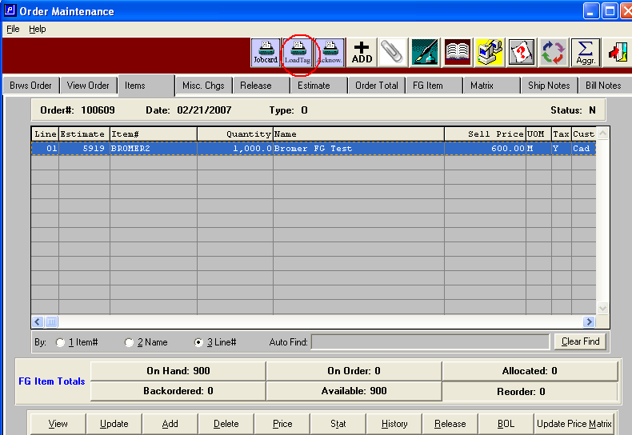

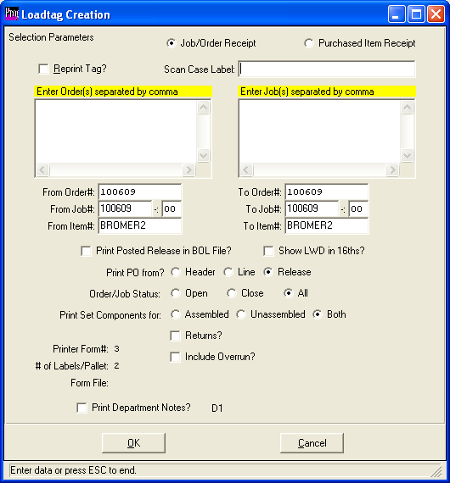

You can also get to this same screen (above) via OU7 (load Tag creation).
You are then presented with a screen that allows you to modify the number of tags to print (which is defaulted from N-K-1 “LOADTAG” which is over-ridden by the tags per unit in the customer file)
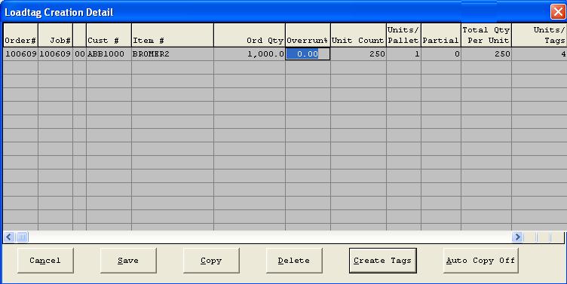

Once you hit the “Create Tags” button (above screen) the text file is sent to the BA/LABEL directory.

When you run Label Matrix you will be able to select the label format (once you used one it is displayed in the “Open recently used label” area).

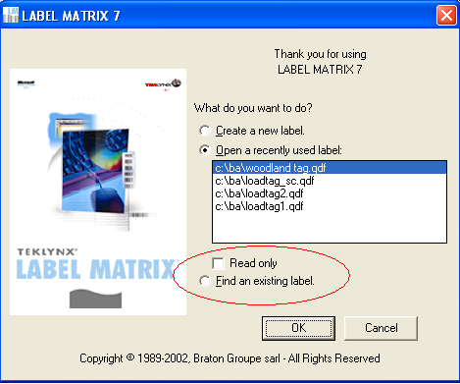

When you select a label format a sample of it is displayed. The “grid” icon on the top of the screen will allow you to display the file of load tag data that was created in Advantzware. You then can use the printer icon, (or the menu option File/ Print) to print the tags.
You can also modify tags and save a custom one to use for your plant.
